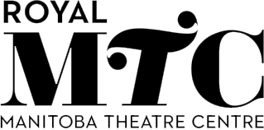

Royal Manitoba Theatre Centre

Accessibility Feedback Form
We welcome and appreciate feedback about accessibility to Royal Manitoba Theatre Centre (“Royal MTC” or “the Theatre”). This could include feedback about access to programs, services, goods, facilities, and the manner in which Royal MTC employees interact with others. You can provide this feedback in person, by contacting Patron Services, or by emailing Accessibility@RoyalMTC.ca

- What is your connection to Royal MTC?
- Patron, Customer, or Facility Guest
- Vendor or Independent Contractor
- Employee or Volunteer
- Other __________________________________________________

- What aspect of Royal MTC does your feedback relate to? Please describe.
- Customer service (e.g., Patron Services, usher, coat check, support with assistive devices) ___________________________________________________________________________
- Information or communication (e.g., ticket sales, performance programs) ___________________________________________________________________________
- Facility (e.g., John Hirsch Mainstage, Tom Hendry Warehouse) __________________________________________________________________________
- Website _______________________________________________________________________
- Other _________________________________________________________________________

- Were you able to access what you needed or wanted to?
- Yes
- No
- Partially

- If you responded No or Partially and experienced difficulty accessing information, goods, services, or facilities at Royal MTC, please describe the problem or barrier you encountered.
______________________________________________________________________________

- If you responded Yes and have any additional comments, please share your feedback here.
______________________________________________________________________________

If you would like someone from Royal MTC to contact you, please provide your contact information.

Name _________________________ Phone ______________ Email _________________________

